**Batch: A2 Roll No.: 16010121045**

**Experiment / assignment / tutorial No. 1**

**Grade: AA / AB / BB / BC / CC / CD /DD**

**Signature of the Staff In-charge with date**

|  |
| --- |
| **TITLE:** a. CProgram to find area and circumference of various geometric shapes.  b. C program to calculate EMI (Equated Monthly Instalment) of loan amount if principal, rate of interest and time in years is given by the user.  (E = (P.r.(1+r)n) / ((1+r)n – 1) |

**AIM:** a. CProgram to find area and circumference of various geometric shapes.

b. C program to calculate EMI (Equated Monthly Instalment) of loan amount if principal, rate of interest and time in years is given by the user.

(E = (P.r.(1+r)n) / ((1+r)n – 1)

**______________________________________________________________________**

**Expected OUTCOME of Experiment:**

CO1: Formulate a problem statement and develop the logic (algorithm/flowchart) for

its solution.

**_____________________________________________________________________**

**Books/ Journals/ Websites referred:**

1. Programming in C, second edition, Pradeep Dey and Manas Ghosh, Oxford University Press.
2. Programming in ANSI C, fifth edition, E Balagurusamy, Tata McGraw Hill.
3. Introduction to programming and problem solving , G. Michael Schneider ,Wiley India edition.
4. [**http://cse.iitkgp.ac.in/~rkumar/pds-vlab/**](http://cse.iitkgp.ac.in/~rkumar/pds-vlab/)

**_____________________________________________________________________**

**Problem Definition:**

**a.** Ask user to enter the input values to compute area and circumference of the given shapes. Put the values in the given formula and print the outcome given by formula on the screen

**b.** Ask user to enter the input values such as principle amount, rate of interest, number of years to compute EMI. Put the values in the given formula and print the outcome given by formula on the screen

**Flowchart: ( for both the sections a and b separately)**

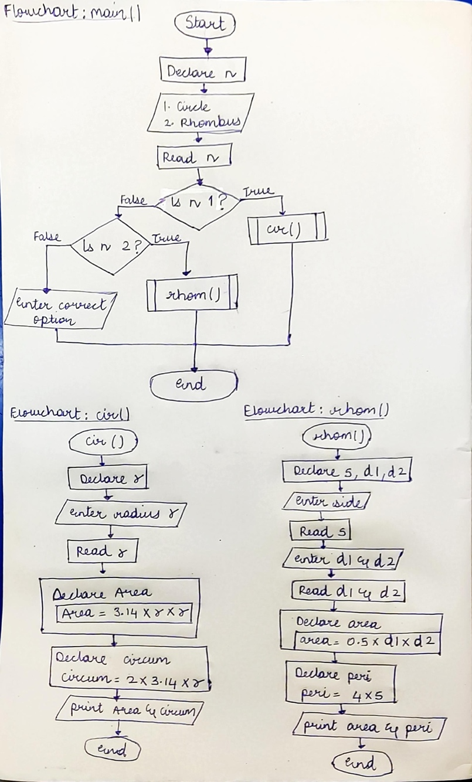**Exp 1a:**

**Exp 1b:**

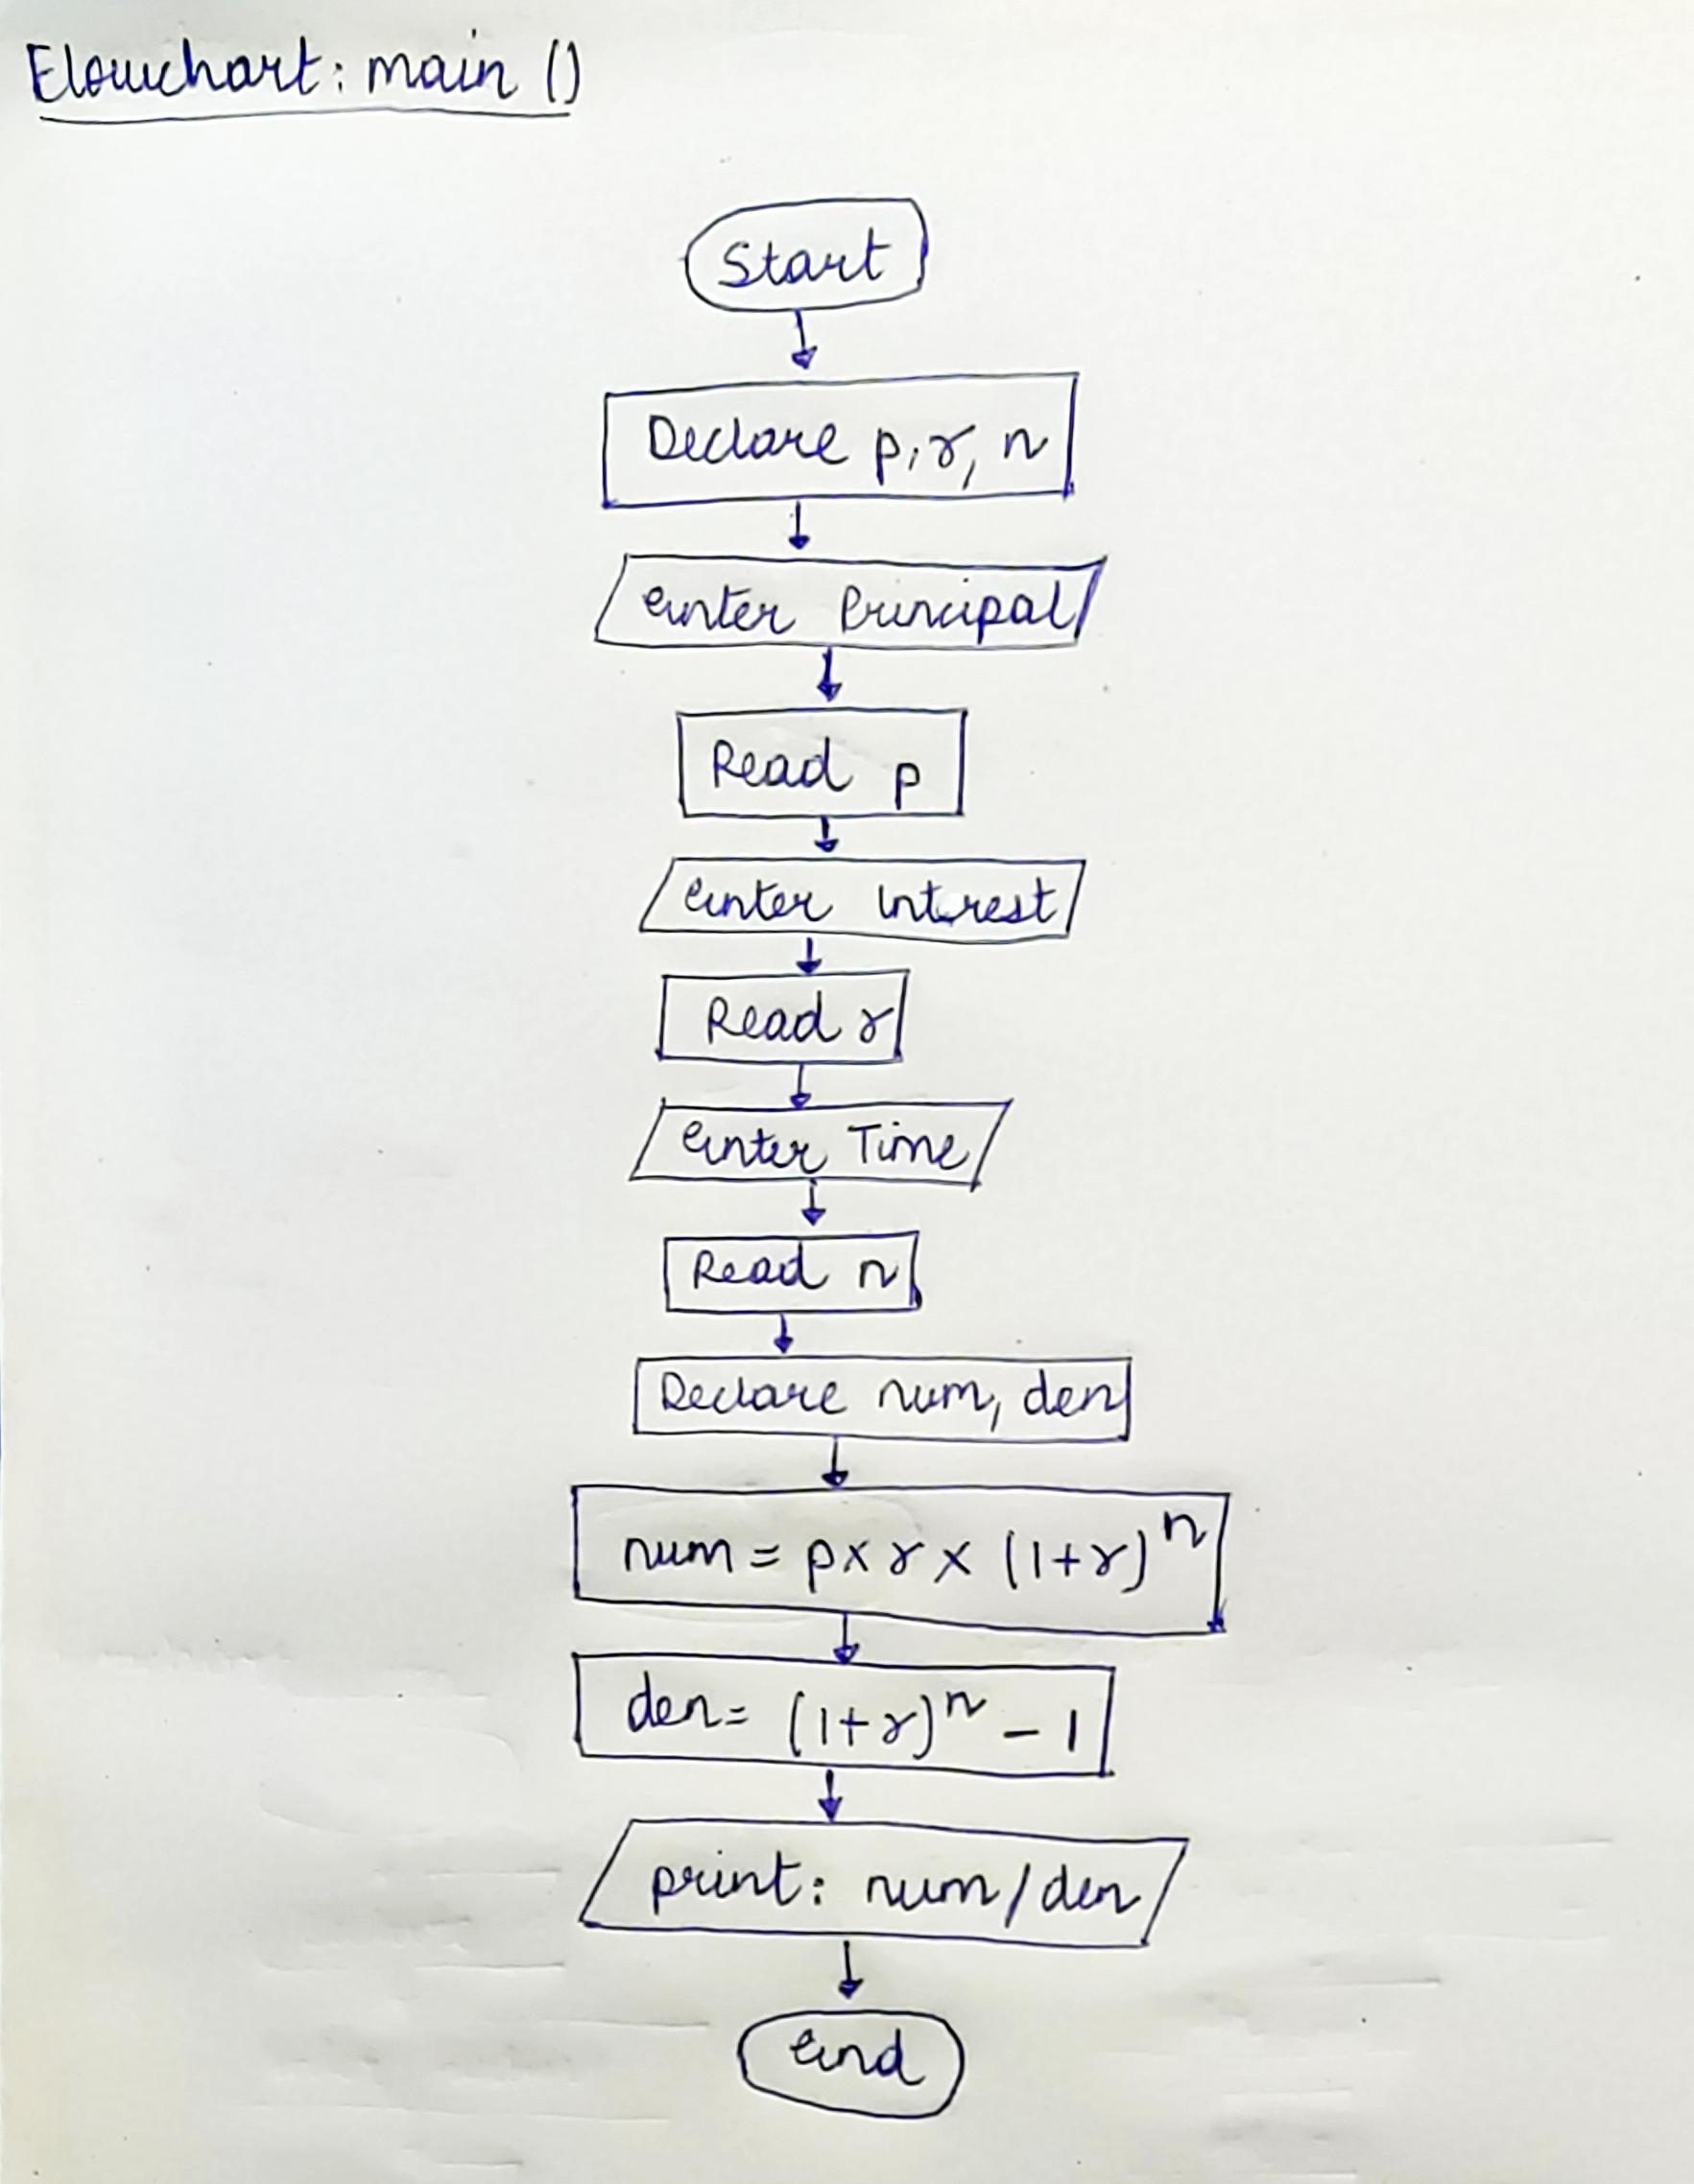

**Implementation details:**

**Exp 1a**



**Exp 1b**

**Outputs :**

**Exp 1a**

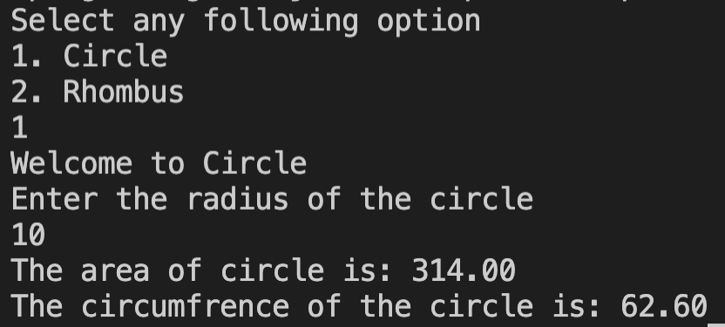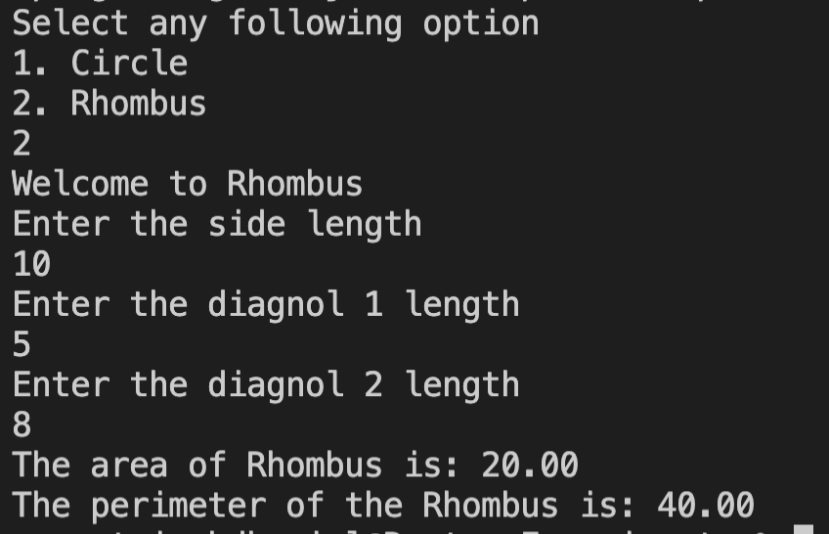

**Exp 1b**

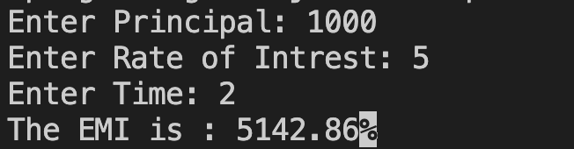

**Conclusion:** Successfully executed out Experiment 1.

**Post Lab Descriptive Questions**

1. **What is problem definition?**
2. **What is a flowchart? What are the standard symbols used to draw a flow chart? Explain in brief.**

**Date: _____________ Signature of faculty in-charge**